

*American Baptist Churches are missional congregations that nurture devoted disciples of Jesus Christ who live their lives in mission and ministry for the healing of the world through the love of God.*

Join with American Baptists around the world  
in February to celebrate ABCUSA Sunday!

This year’s theme, ***"Serving with Love, Transforming through Mission,"*** captures the essence of our calling. This special event offers a wonderful opportunity for us to come together in unity and purpose, honoring our history while looking forward to our future. As Matthew 28:19-20 reminds us, "Therefore go and make disciples of all nations… and surely I am with you always, to the very end of the age."

*Our church will be celebrating on:  
FILL IN YOUR DATE*

*Theme:****Serving with Love,   
Transforming through Mission***

On ABCUSA Sunday, American Baptists will celebrate what it means to be American Baptist through our history and Baptist distinctives, and join together in prayer. Include in your celebration:

* Prayer for the ABCUSA Office of the General Secretary and its work in Gathering the Denomination, Supporting Congregations, Regions and National Organizations, and Creating Space for Local and Global Issues.
* Prayer for our many partners in mission, including our leaders, pastors, global servants, staff, regions, and churches.
* An invitation to Come Seek Living Water at the 2025 Biennial Mission Summit, July 3-6, 2025 in Omaha, Nebraska. (Learn more at [www.AmericanBaptists2025.com](http://www.AmericanBaptists2025.com))
* 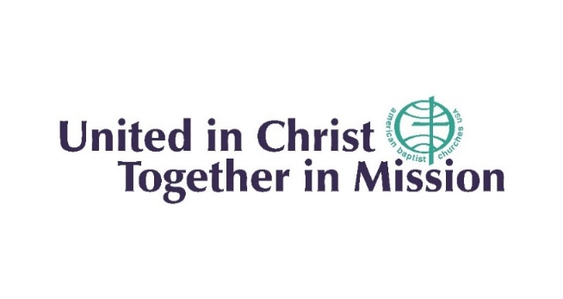Give thanks for how God has blessed us with a rich history and in faith as we continue to seek God’s mission.

**We are**

Let's join together in embracing the spirit of mission and discipleship as we celebrate ABCUSA Sunday. Your active participation and sharing in February will help spread the message of our collective mission.

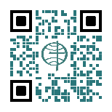

Find materials on the ABCUSA website at   
[www.abc-usa.org/ABCUSASunday](http://www.abc-usa.org/ABCUSASunday).